Winch control manual

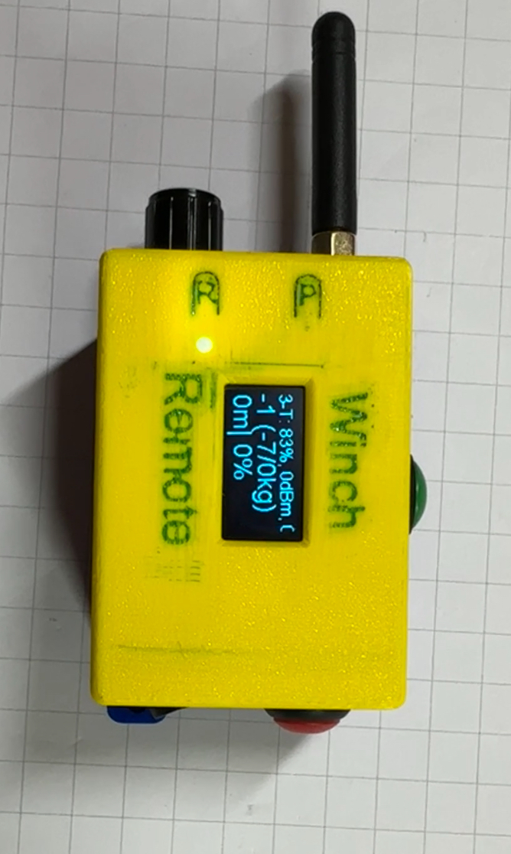

BTN UP

BTN DOWN

Setup Switch

Lora Antenna

Switch

ON / OFF

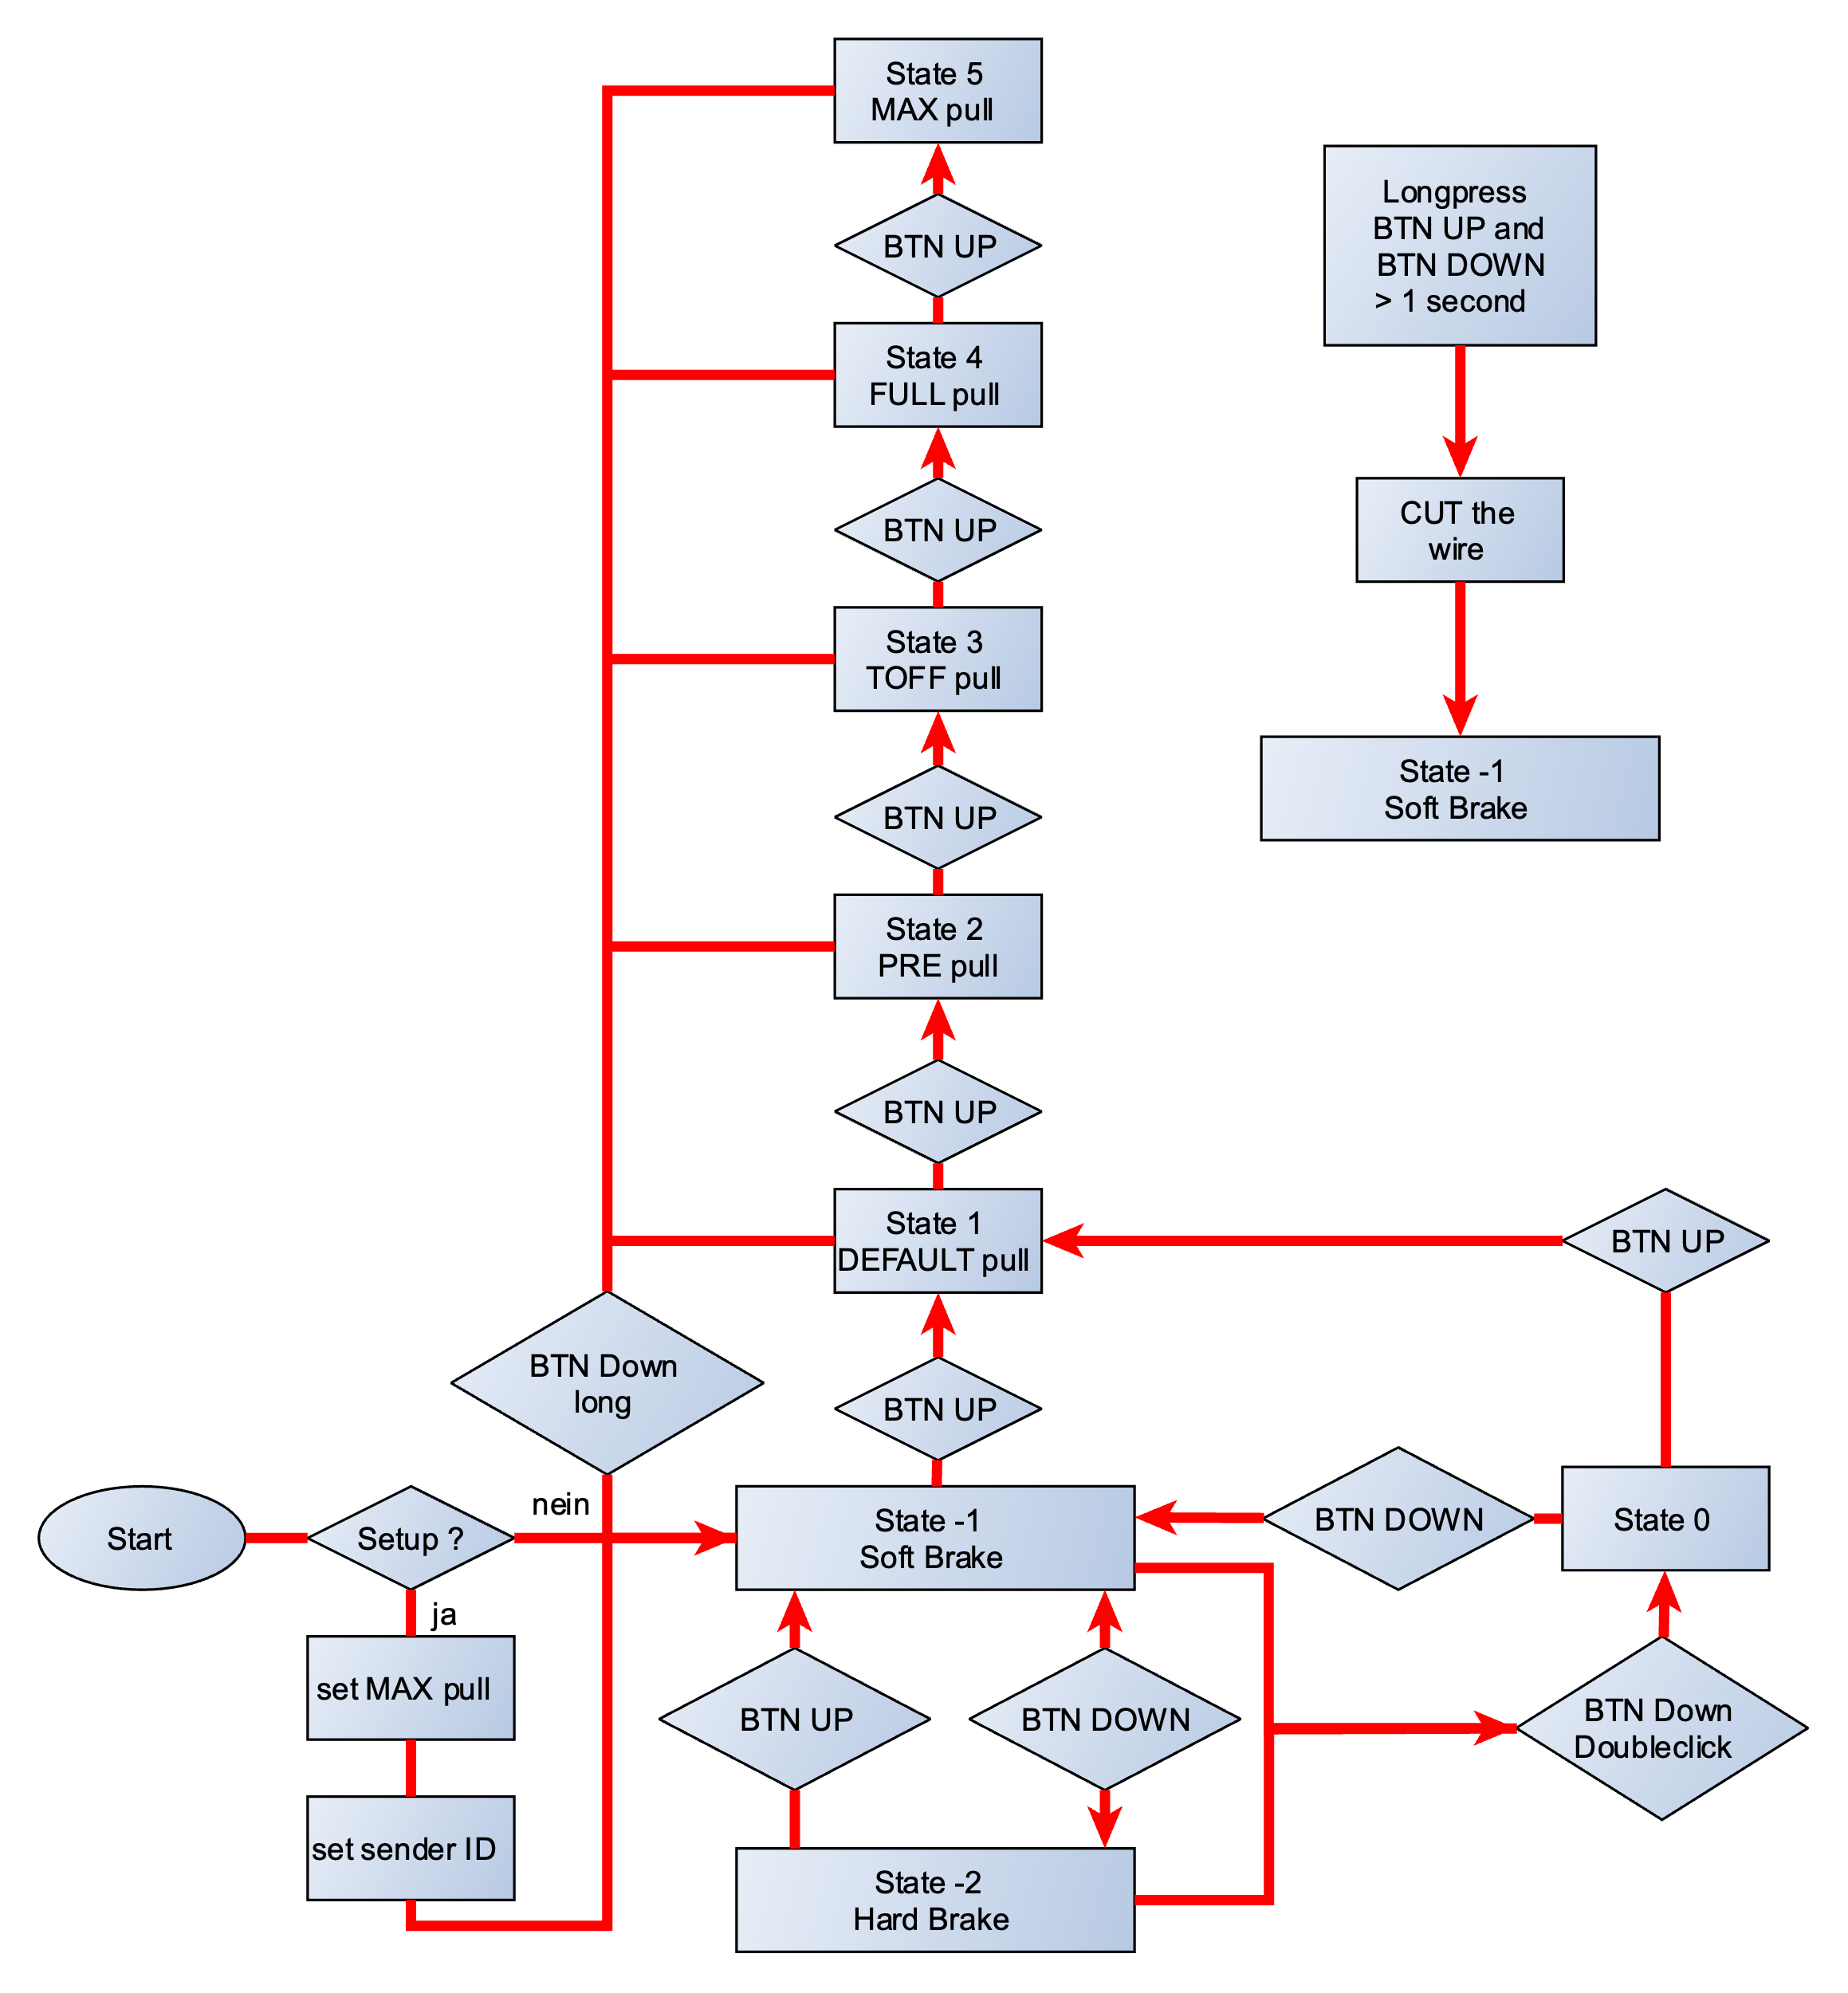

Remote Display

Due to the fact that the display on the remote control is hard to read while towing I made a display connected by ESP-NOW to the remote control.

This can be attached to the cockpit and is easy to read.

